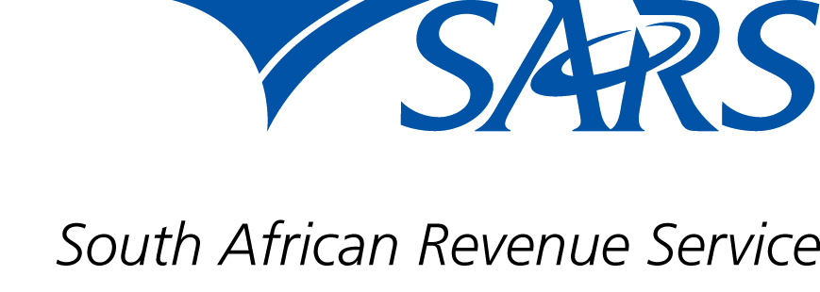

Dear Stakeholder

TAX DIRECTIVES: TRADE TESTING DATES AND SOFTWARE IMPLEMENTATION

SARS will introduce enhancements to the Tax Directives process as indicated in the IBIR-006 Tax Directives Interface Specification Version 6.303. The trade testing dates are planned for 22 March 2022 – 14 April 2022. This is to prepare for the implementation of the software during the first quarter of the 2022/23 financial year with the changes officially being implemented on 22 April 2022. Please be advised that in the event that these dates change, you will receive communication from SARS.

The Tax Directives Interface Specification is available on the SARS website www.sars.gov.za and you are encouraged to review the document prior to testing.

Please follow these steps to submit test files:

Step 1: Before testing can commence, you will need to email 10 taxpayer reference numbers to ncts@sars.gov.za to ensure the numbers are active. In the email subject line, use “Tax reference numbers for Trade Testing”. A maximum of 10 taxpayer reference numbers will be allowed.

Step 2: You will be notified via the same email address to confirm when testing may commence.

For trade testing queries please email ncts@sars.gov.za

Sincerely

THE SOUTH AFRICAN REVENUE SERVICE

March 2022

