RFP 28/2025: Panel of Design and Engineering
Question & Answers

# | Question | Answer
1. | When tendering for each category = 1 tender document per category (i.e Fire / Civil/ Struct etc.) | Yes, to ensure that there is no confusion on the side of the Evaluation Committee and a category tendered for is not missed.
2. | Should we have offices in one or more provinces, does it mean that 1 office can tender per category and tick all the clusters or is it 1 category tender per region) | No, it is not necessary to have an Office in each region if all Regions are bided for. But keep in mind when individual requests are sent out, there might be a cost implication, i.e. travel cost, S&T, etc
3. | I would like to find out if we need to submit a tender pack for each cluster we apply for or is that only applicable if you are bidding for different categories? | If you are offering the same professional service per cluster, just submit one tender pack per Cluster. Please make sure it is every clear that all Clusters are bided for and the exact category.  If it is more that one cluster, with more that one category, separate tender packs would be preferred.
4. |  | - No, it was indicated as such during the briefing session.  - No minimum CV per category  - A copy of the certification is preferred  - Academic qualifications to be certified please.  - No financial statements are required this round  - It could just be to your advantage to include a BEE Certificate, but it will not be evaluated. Only when individual bid for specific projects are requested.
5. | During the briefing it was advised that we may do one submission for multiple clusters so long as each cluster is clearly marked in the submission, and later, during the briefing, it was advised that we submit a separate submission for each cluster. For example: If we are submitting for 2 Categories within 5 clusters,  Are we required to submit 10 separate submissions as follows:  - Category A – Cluster A  - Category A- Cluster B  - Category A – Cluster C  - Category A – Cluster D  - Category A – Cluster E  - Category B – Cluster A  - Category B - Cluster B  - Category B - Cluster C  - Category B - Cluster D  - Category B – Cluster E  Each in a separate Lever arch file or can we submit 2 submissions and just clearly state the clusters that we are submitting for.  - Category A – Clearly mark each cluster  - Category B – Clearly mark each cluster  Each in a separate Lever arch file | Yes, lease to avoid any confusion, separate files is required.
6. | We are a consulting firm and specialize on both Civil and Structural Eng, do we have to submit 2 separate bids for each discipline or we can submit both disciplines on 1 bid? | Please submit 2 separate bids. Please remembers to clearly define and indicate the Regions, included
7. | 1). Will references without client’s letterhead but with client’s signature and stamp be sufficient?  2). May the Principal QS also act as one of the professional resources? | 1. References on clients letterheads, duly signed please  2. Yes
8. | 1)Will references without client’s letterhead but with clients signature and stamp be sufficient?  2). May the Principal QS also act as one of the professional resources? | 1. References on clients letterheads, duly signed please/
9. | Will the minutes of the briefing held today be made available for the interested bidders or do we have to request for them? | No, as confirmed during the briefing session
10. | 1. If we are bidding for Structural, Project Management, and Quantity Surveying, and our Principal is also a Structural Engineer, can the Project Manager and Quantity Surveyor be included under the three required resources — with the Principal as Structural Engineer and the other two as QS and PM?  2. Will the appointed consultants be based in our office? | 1. Yes, if it is one company  2. Yes. SARS might require site visits and on-site meetings and consultation, but SARS will not provide Office Space.
11. | May we please request that the project references be within the past 10 years as opposed to the 7 years requested | Yes, if applicable and comply with SARS’ stipulated requirements
12 | The table indicates that a PR certificate is required for each selected category (Categories 1–9: Various Disciplines); however, there is no table or description outlining what each category entails. We are therefore unsure how to indicate which categories we are bidding for  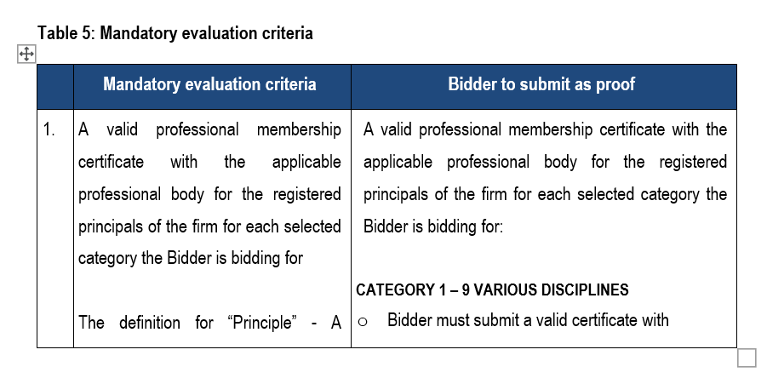 | Yes, there is a table. Please refer to Annexure A, par 3 and 6 and Annexure B, par 2 of the official tender document issued.
Please advise on the following below for Tender No: RFP28/2025.

• Tender completion can the tender be typed out as the space are limited to write in black ink.
General and Important
7. | Bidders must carefully read the RFP document.
8. | Bidders are advised to regularly visit the SARS website for any updates.

