Ukukhokha nge-eFiling (credit push)
I-eFiling credit push umyalelo wokukhokha ovikelekile phakathi kukaSARS eFiling kanye nebhange onika ikhasimende amandla okulawula lapho likhokha. Phinda ubheke ukuthi isebenza kanjani indlela yokukhokha ku-eFiling.
Isungqangi: Amakhasimende okuLawulwa Kwempahla Emngceleni neNtela yempahla angakwazi ukukhokha kuphela efomini lokudalula/lokubuyisa intela noma i-eAccount ku-eFiling, funda kabanzi.
Ngenza kanjani ukuze ngikwazi ukukhokha ngohlelo lwe-Credit Push ku-eFiling?
Ngokukhokha nge-eFiling, ungakhokha wena njengomuntu obhalise ku-eFiling, isib. umkhokhintela, isisebenzi sentela, ommelele, kodwa lokhu kukhokha kumele kugunyazwe umnikazi we-akhawunti yasebhange. Uma ukhokha kwaSARS, i-eFiling izothumela isicelo sokukhokha ebhange lakho esizobe siveza inani okumele likhokhwe okudinga ukuba ligunyazwe bese kukhishwa inombolonkomba yokukhokha. Umnikazi we-akhawunti yasebhange kumele ebe esefaka umkhiqizo wakhe wasebhange bese ugunyaza lesi sicelo, okuba umyalelo oya ebhange ukuba likhokhele abakwaSARS.
Ukukhokha okwenziwe nge-eFiling akujikiseki futhi ngeke ukwazi ukukubuyisa noma ibuyiselwe emuva.
Ukuze ubone indlela yokusebenzisa i-eFiling ngemininingwane yasebhange, landela lezi zinyathelo ezilandelayo.
Izinyathelo zokusebenzisa i-eFiling ngemininingwane yasebhange yilezi:
Ngaphambi kokusebenzisa indlela yokukhokha nge-eFiling, kumele uqale uqinisekise ukuthi ibhange lakho liyawemukela amathransekushini e-credit push.
Isungqangi: Khulumisana nebhange lakho mayelana nokungena ku-akhawunti eyemukela i-credit push.
Kubantu ngamunye, cofa ku-‘Home’ ngenhla lapho kucingwa khona:
Kulandele u-‘User’ ngakwesokunxele lapho kucingwa khona bese uya ku-‘Banking Details’:
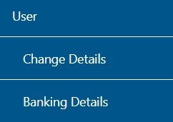
Izinhlangano noma izisebenzi zentela, cofa ku-‘Organisations’ ngenhla lapho kucingwa khona:
Kulandele u-‘Organisation’ ngakwesokunxele lapho kucingwa khona bese uya ku-‘Banking Details’:
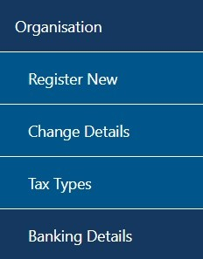
Uma kwenzeka udinga ukufaka i-akhawunti entsha, cofa ku-‘Setup New Account’:
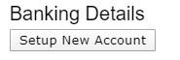
Kungenjalo, ungalandela izinyathelo ezilandelayo ukuze ufake imininingwane yasebhange.
Cofa ku-“Returns”, bese kuba u-“Payments” ngakwesokunxele lapho kucingwa khona bese kuba ku-“Bank Details Setup” ukuze ufake imininingwane yakho ku-eFiling.
Okuba kumenyu kuhluka phakathi kwamaphrofayili omuntu siqu, inhlangano kanye nesisebenzi sentela. Ngezansi isibonelo sephrofayili yomuntu kanye nenhlangano kumenyu.
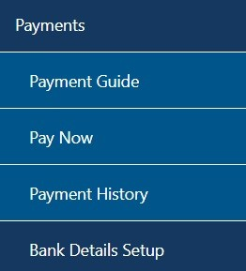
Kuzobe sekuvela isikrini esibhalwe “Banking Information”. Ukukhetha i-Credit Push kuzozikhethekela ngokwakho.
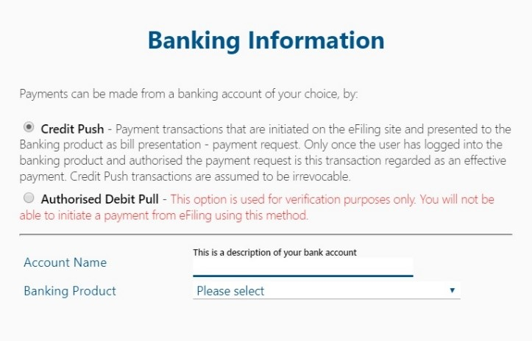
Uma ukhethe i-“Banking Product”, kuzovela uhla lwamabhange. Khetha ibhange elifanele.
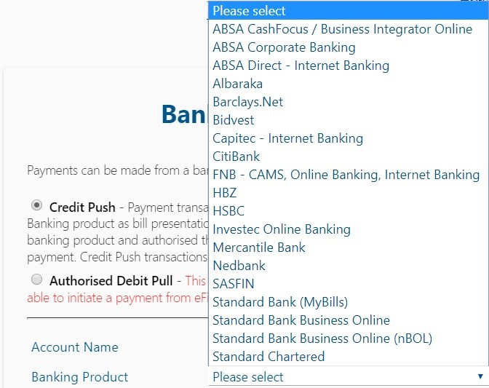
Emva kokukhetha ibhange, kuzobe sekuvela indawo yokufaka inombolo ye-akhawunti ukuze uyigcwalise. Gcwalisa le ndawo bese ukhetha u-“Save” ukuze uqhubeke noma u-“Back” ukwenza izinguquko olwazini lwasebhange olufakiwe.
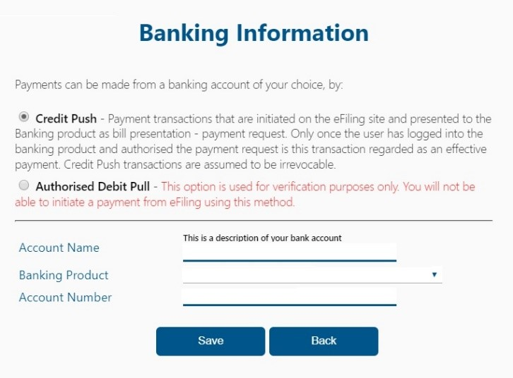
Emva kokugcina imininingwane yasebhange, imininingwane izobe isigcinwa ku-eFiling njengoba kutshengisiwe ngezansi.
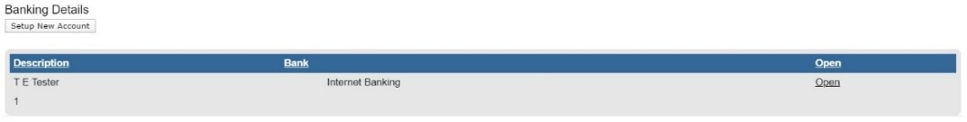
Uma ucofa ikhonco elithi “Open”, kuzovela ikhasi elinolwazi lwasebhange.
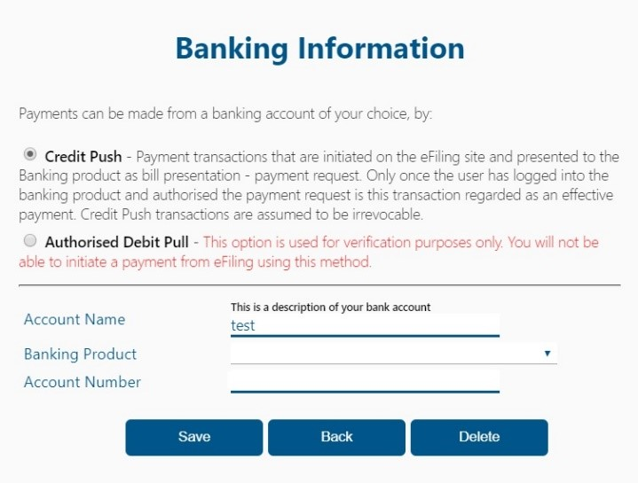
Ukuze ususe imininingwane yebhange, cofa ikinobho elithi “Delete”. Cofa ku-“OK” ukuqinisekisa ukuthi uyayisusa imininingwane yebhange noma ku-“Cancel” ukvala umyalezo.
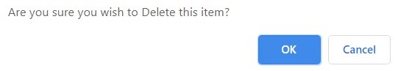
Emva kokuqinisekisa ukususwa kwemininingwane yebhange, ayikho imininingwane yebhange ezovela ekhasini le-eFiling.
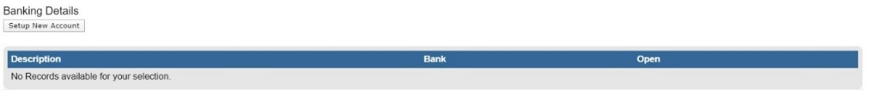
Isungqangi: I-Credit Push ifakwa kanye kuphela.
Uma inkokhele isiyenziwe ku-eFiling uzodinga ukuba ungene emkhiqizweni wakho wasebhange bese ugunyaza ithransekushini.
UKUQINISEKISWA KWEMINININGWANE YEBHANGE lapho ufaka uhlelo lokukhokha nge-credit push
- Lapho amakhasimende e-Investec bank, i-Citi bank SASFIN Bank kanye ne-Albaraka Bank efaka imininingwane awo ebhange ukuze akhokhe ngeeFiling; imininingwane yebhange iqinisekiswa yibhange ukuze liqinisekise ukuthi isikhungo siyiso.
- Ngezansi imininingwane yekhasimende eqinisekiswa iqhathaniswa nemininingwane ye-akhawunti yebhange; ngesikhathi kukhokhwa ngenqubo yohlelo lwe-credit push kumabhange angenhla.
  - Imininingwane yasebhange.
  - Isikhungo esizoba yinombolo yokuhlonza abantu siqu.
  - Inombolo yokubhalisa inkampani (uma kuyinhlangano) kanye nenombolo yethrasti uma kuyithrasti.
- Uma imininingwane yebhange isifakelwe inqubo yohlelo lwe-credit push, cofa ikinobho elithi “save”. Esimweni lapho imininingwane yekhasimende yephrofayili ye-eFiling ifana nemininingwane yebhange, imininingwane yebhange efakiwe izobe isifaneleka enqubweni yokuqinisekisa.
- Uma inombolo yokubhalisa isikhungo efana nenombolo kamazisi / inombolo ye-CK / inombolo yethrasti kuphrofayili ye-eFiling ingaqondani nesebhange. Kuzovela umyalezo oqinisekisa ukuthi ukuqinisekiswa akubanga yimpumelelo othi “Account verification request not successful – The entity registration number does not match the identification registered for this account/profile”.
- Imininingwane yekhasimende ebhalise i-eFiling engahambisani nemininingwane yasebhange inqubo yokuqinisekisa ayibi yimpumelelo; noma uma kukhona okuvimbayo ebhange okuthinta izimali ku-akhawunti kuzovela umyalezo othi “Account verification request not successful, there is a hold /profile that does not allow this transaction to be processed”.
- Amakhasimende ayelulekwa ukuba aqhathanise imininingwane ebhaliswe ku-akhawunti yasebhange naleyo ekuphrofayili ye-eFiling bese belungisa lapho kunesidingo.

