Ukukhuluma Ngodaba Losizo

Faka isikhalazo

Usizo esifuna ukukunika lona
Sifuna ukukuhlinzeka ngosizo oluseqophelweni eliphezulu noma ngabe sidingida intela yakho siqu, intela yengenisomali lenkampani, izinto ozenzayo uma ungenisa impahla ezweni noma uthelekisa, noma naziphi ezinye izintela esizisingathayo. Siyazi ukuthi kubaluleke kangakanani ukwenza izinto ngendlela eyiyo, ngakho-ke sihlala sifuna izindlela zokwenza ngcono. Njengengxenye yokuletha izinsiza kubantu, sesethule indlela entsha ongafaka ngayo isikhalazo uma kungukuthi awuthokozile ngendlela ophathwe ngayo kwaSARS emva kokulandela izinqubo ezijwayelekile. Ngolwazi olwengeziwe, sicela ubheke Umqulu wethu Wezinsizakalo.

Indlela yokukhalaza
Zintathu izindlela ongakhetha kuzo zokuthumela isikhalazo sakho:
- Ngokuya ku-eFiling, cofa lapha ukuze ungene ku-eFiling bese ufaka isikhalazo. Bheka isiqondiso sesinyathelo ngesinyathelo sendlela yokufaka isikhalazo ngokusebenzisa i-eFiling. Sicela uqaphele ukuthi kumele kube ukuthi ubhalisile ku-eFiling. Uma ungakabhalisi, cofa lapha.
- Vakashela igatsha lakwaSARS eliseduze. (Ngesikhathi somvalelandlini, ukuvakashela egatsheni kunemikhawulo ethile futhi kwenzeka ngokubeka usuku lokuya khona kuphela)
- Ngokushayela iHhovisi lokuSingathwa kweziKhalazo lakwaSARS (CMO) kule nombolo 086012 12 16.
Isungqangi: Ifomu lofaka isikhalazo awukwazi ukulidawuniloda noma ukuthi siligaye bese silithumela kuwe. Yifomu ongakwazi ukulithola ku-inthanethi kuphela okumele uligcwalise ku-eFiling, i-ejenti yakwaSARS izogcwalisa ifomu egameni lakho uma uxhumana ne-CMO, i-SARS Contact Centre, igatsha lakwa-SARS, noma uMahambanendlwana weNtela.

Isikhathi sokufaka isikhalazo
Uma ungathokozile ngosizo olutholile emva kokuxhumana nabakwa-SARS, ungafaka isikhalazo. Kwesinye isikhathi sizodinga ukuthi ube nenombolo yecala esemthethweni. Isikhalazo isenzo esikhalisayo noma esingakwenelisi ngandlela thize wena njengomkhokhintela, umhwebi, noma ummeleli okumayelana nenqubo (kubandakanya imibuzo, amaphepha okubuyisa intela noma nasiphi isicelo sanola iluphi usizo), noma obhekene nakho ufuna ukusizwa okungazange kusonjululwe ngokwanele.
Isungqangi: Kodwa-ke, uma uphikisana nomphumela wokubuyekezwa noma ngesinqumo esithathwe abakwaSARS, kumele uphikisane nalokho noma ulandele inqubo yokusonjululwa kwezinkinga, bheka incwajana eyisiqondiso sokusonjululwa kwezinkinga. Sicela uqaphele ukuthi inqubo yokusonjululwa kwezinkinga ayiyona ingxenye yenqubo yokufaka isikhalazo. Uma ungavumelani nenhlawulo, kumele ulamdele inqubo yokusulwa kwesikweletu ebizwa nge-Request for Remission ngaphambi kokuphikisa.
Uma ungathokozile ngosizo oluthole kwaSARS noma ngezinqubo, bheka ngezansi izindlela ongazilandela:
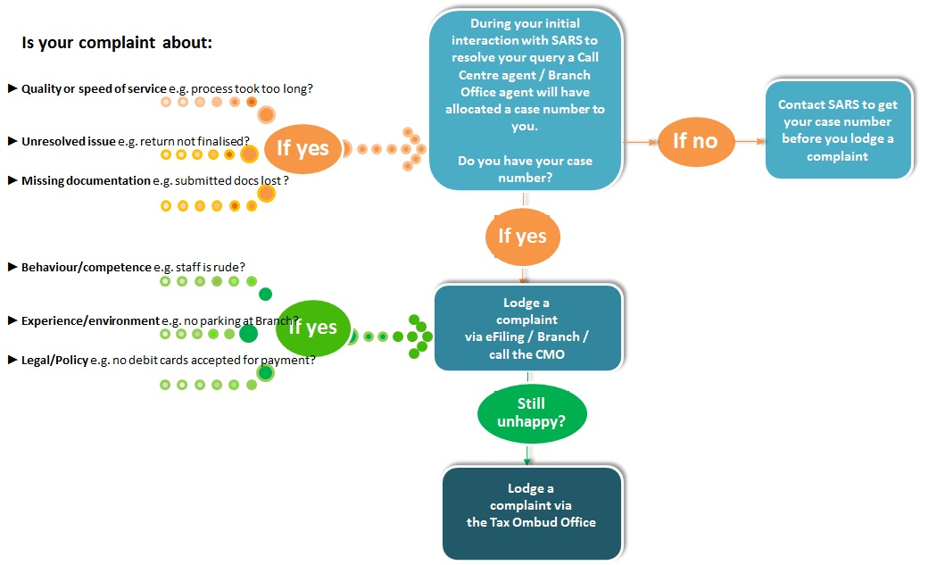

Izinhlobo zezikhalazo
Ngezansi uhla kwezinhlobo zezikhalazo. Sicela ukhombise isigaba esiyiso uma uthumela isikhalazo sakho:
Inombolo | Isigaba | Isibonelo
1 | Okomthetho/Inqubomgomo | Isibonelo, ama-debit cards awemukelekile ukwenza  izinkokhelo.
2 | Indlela yokuziphatha kwesisebenzi/ulwazi lwaso lomsebenzi | Isibonelo, i-ejenti X ubeluhlaza, noma i-ejenti ibingazi  ukuthi kumele ingisize kanjani.
3 | Izinkinga obhekane nazo ngomgudu/indawo/ezobuchwepheshe | Isibonelo, isikhungo sezingcingo sithatha isikhathi  ngaphambi kokuphendula izingcingo, noma ayikho indawo  yokumisa izimoto egatsheni X.
4 | Izinga nokushesha ukuthola usizo* | Isibonelo, ukuxazululwa okungekona kwesicelo, noma  kuthathe izinyanga eziyi-6 ukushintsha imininngwane  yami yasebhange.
5 | Udaba losizo olungaxazululiwe/lokusebenza* | Isibonelo, isikhathi sokuthola usizo sidlulile  kwesibekiwe kanti amaphepha ami okubuyisa intela  awakasetshenzwa.
6 | Amadokhumenti adukile noma alahlekile* | Isibonelo, ngiwathumelile amaphepha ami entela, kodwa  abakwa-SARS abawatholi.
* Udinga ukuthola inombolo yecala kuqala kulezi zinhlobo ezintathu zokugcina. Ngamanye amagama, uma isikhalazo sakho simayelana 'nezinga nokushesha ukuthola usizo', 'udaba olungaxazululekile losizo/ukusebenza' noma 'kungamaphepha adukile noma alahlekile', isikhalazo sizokwemukelwa kuphela uma selikhona vele icala elivuliwe futhi inombolo yecala isifakiwe efomini. Kungaba inombolo yecala yokuqala noma inombolo yecala yokulandelela.

Ngaphambi kokufaka isikhalazo
Ngaphambi kokuthi ufake isikhalazo, uyacelwa ukuba
- Ukhulumisane nenduna noma umphathi oxhumana naye ukuze nisombulule udaba losizo nabakwaSARS.
- Ushayele i-SARS Contact Centre (0800 00 7277) uma udaba lungatholi ukuxazululeka.
- Qinisekisa ukuthi uyayithola inombolo yecala ngoba uzodinga le nombolo yecala uma ufuna ukuqhubeka nokufaka isikhalazo.
Uma usuzilandele zonke lezi zinqubo usungasifaka-ke isikhalazo.

Ongakulindela emva kokuba ukhalazile
Uzothola umyalezo omfishane i-SMS noma isaziso ezigabeni ezehlukene zenqubo:
- Uma ususifakile isikhalazo sakho, uzothola okukwazisayo ukuthi isikhalazo sakho sisitholile ngalo lelo langa.
- Usuku lwesixazululo lungeke lwedlule ezinsukwini ezingama-21 emva kokufakwa kwesikhalazo.
- Lapho ungenelisekile ngomphumela, ungalandela inqubo eyaziwa nge-Tax Ombud process.

